VOLUNTEER APPRECIATION

Feb 24th, 2018

Dear Jason Wei,

On behalf of the Asian-Canadian Special Events Association, thank you very much for serving as a volunteer General Volunteer for 2018 TAIWANfest - “Fete with the Philippines”. You competed 10 hours of volunteering on 32.

Thank you again for your dedicated service to support TAIWANfest - “Fete with the Philippines”. We hope it was a meaningful and inspiring experience for you. We would like to take this opportunity to say a heartfelt “Thank You!” and look forward to working with you again soon.

Sincerely,

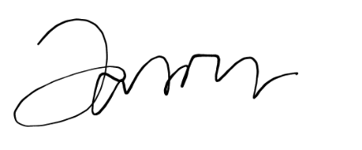

Jason Wei

Volunteer Coordinator

